Name:  Teacher : | ____________________________________  ______________________ |  | Date:_________
 | Year 7  / 34  Test 1 - Fractions  Full working out MUST be shown to get full marks for each question.
Total Time: | 45 minutes
Weighting: | 5%
Equipment: | One A4 page of notes (one-sided), times table chart, pen, pencil, eraser

Multiple Choice Section [5 marks]
- Estimate which answer is less than 1

- $\frac{1}{3}+\frac{1}{2}$
- $2-\frac{1}{4}$
- $\frac{5}{6}+\frac{1}{3}$

- Which fraction is the same as 80%?
- $\frac{3}{5}$
- $\frac{3}{4}$
- $\frac{4}{5}$
- How much is $\frac{2}{5}$of 35?
- 14
- 70
- 7

- Which fraction is equivalent to $\frac{1}{3}$?
- $\frac{4}{16}$
- $\frac{5}{15}$
- $\frac{5}{18}$

- A fraction where the numerator is equal to, or larger than the denominator is also known as
- Improper fraction
- Proper fraction
- Mixed number
- Denominator
Short Answer Section [29 marks]
- At the local swimming pools $\frac{1}{4}$of the people are men, $\frac{1}{3}$of the people are women and the rest are children. If there are 420 people at the pools, how many are children? [4 marks]

- What fraction of this shape is shaded? Write the answer in its simplest form. [1 mark]
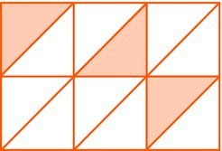

- Using the following diagrams colour in two fractions that are equivalent to each other [1 mark]

- Write 3 fractions. One that is less than, greater than and equivalent to $\frac{1}{2}$ ? [3 marks]

- Write the following fractions from smallest to largest [2 marks]

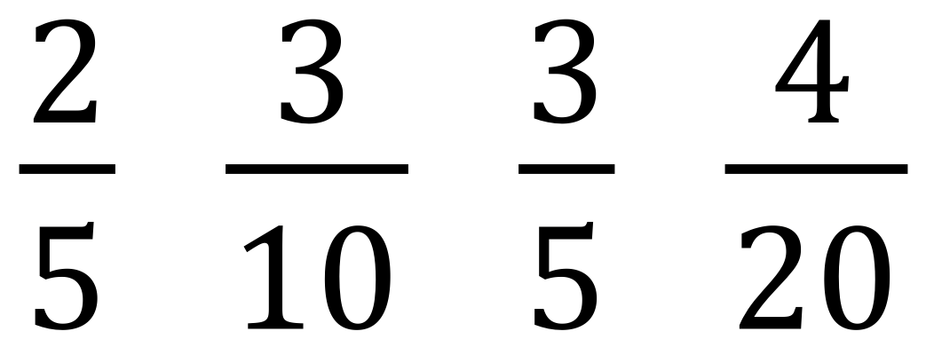

- Write the fractions marked by a dot on the number line [4 marks]

- Evaluate the following. Make sure you leave your answers as proper or mixed fractions. if possible, simplify your answer [10 marks]

- $\frac{2}{3}+ \frac{2}{3}$ d) $\frac{2}{3}+ \frac{1}{4}- \frac{2}{5}$

- $\frac{1}{4}+ \frac{2}{3}$ e)$\frac{2}{5} × \frac{4}{7}$

- $1\frac{5}{6}- \frac{3}{12}$

- Mr Pitt asked the class the following fractions question $\frac{7}{8} ÷ \frac{4}{5}$ . Three students in the class gave three different answers [4 marks]
Jasmine: $\frac{32}{35}$ Benjamin: $1\frac{3}{32}$ Dwayne: $\frac{28}{40}$

Which two students were incorrect and explain WHAT mistake they may have made when working out the answer.

